1. **Project Background**

**Moodle** is a learning platform designed to provide educators, administrators and learners with a single robust, secure and integrated system to create personalised learning environments. You can download the software onto your own web server or ask one of our knowledgeable Moodle Partners to assist you.Moodle system is a free and open-source learning management system (LMS) written in PHP and distributed under the GNU General Public License. Developed on pedagogical principles, Moodle is used for blended learning, distance education, flipped classroom and other e-learning projects in schools, universities, workplaces and other sectors. With customizable management features, it is used to create private websites with online courses for educators and trainers to achieve learning goals.Moodle allows for extending and tailoring learning environments using community-sourced plugins.

* **Front Page**

The front page is the initial page seen by someone reaching a Moodle site after or before a login. Typically a student will see courses, some blocks of information, displayed in a theme. In the Navigation bar and Navigation block it is called "Home”.A combination of site policies, user authentication and front page settings determine who can get to the front page. And once they get there what they can see and what they can do.In many ways, a Front Page has similar features and functions to those in a Course.

* **Log in As**

The capability moodle/user:loginas allows a user to log in as any other user, apart from administrators. This capability may be applied in the course or system context. If applied in the course context, it allows a user to login as admin, professor or as a student.

* **Dashboard**

is a customisable page for providing users with details of their progress and upcoming deadlines. In the centre is the Course

overview block which allows students and teachers to easily track required activities and filter courses.

* **User Menu**

The user menu can be accessed by clicking next to your user name at the top right of the Dashboard, the home page, or most other pages in your Moodle site. When you click on the small triangle next to your user name, a dropdown menu will show links to your dashboard, profile, grades, messages and your preferences. There will also be a link to log out of the site, and (if you are a teacher or admin) there may be a link that allows you to Switch your role

* **User Profiles**

Every user has a profile page which may be reached from the user menu top right and then clicking Profile. This page contains links to further pages allowing the user to edit their profile information and preferences, view their forum/blog posts, and check any reports they have access to.

* **Course List**

Every student, professor, admin or new enrolees can access this part of moodle. You can view available courses and how many slots left to enrolled on your choice course

* 1. **Project Management**

**1.1.1 Business Case**

**1.1.1.1 Executive Summary**

Learning Management System (LMS) is used to promote quality education and training through an on-line and partially automated system creating a virtual environment for the instructors and students to communicate among them at a single platform with all available resources and learning material.

**1.1.1.1 Issue**

|  |  |
| --- | --- |
| **ISSUE** | **DESCRIPTION** |
| **Subjects**   * Having trouble on subjects | Subjects appear even you didn’t enroll on those curriculum |
| **Security**   * Easy to hack accounts | Easy to hack accounts using default student id and password |
| **Forgot Password**   * Recovery Code on email | Provided email or number didn’t receive recovery code. |
| **Test/Quiz Results**   * Incorrect Test or Quiz results | Inaccurate test or quiz results on activities or exams. |
| **Lost Files**   * Missing submitted files | Activities files are not recorded or nowhere to be found |

**1.1.1.1.2 Anticipated Outcomes**

The Development Team seeks and provide improvements on lms moodle by fixing bugs and improving its features. The team also wants to add other functions that will help students, professor and parents to monitor the activities and performances of each individuals and to lessen error while using lms moodle.

* + - * 1. **Recommendation**

**1.1.1.2 Business case analysis team**

|  |  |  |
| --- | --- | --- |
| Role | Description name | Name |
| Project Manager | The one who manage the development team | Vince Benzal / Member Team |
| Business Analyst | The person who analyze an organization and documents its business, process, and system. | Joshua Domingo / Member Team |
| Process Improvement | Advises the team for a better approach on the process also helps the team to improve their individual techniques. | John Glenn Laynesa / Member Team |
| Technical Support | Provides all technical support for the project | Kenneth Dave Quilingen / Member Team |
| Software Support | Provides all software support for the project | Michael John Realizan / Member Team |

**1.1.1.3** **Problem Definition**

**1.1.1.3.1** **Problem Statement**

* + - * **Online payment -** Can’t generate online transaction, the online transaction and the bank transfer are not available.
      * **Slow Process –** Slow loading when there is a lot of students using the app or website at the same time.
      * **Account recovery –** Can’t generate code that will be sent to account provided email when you forget your user or password.  
          
        **1.1.1.3.2 Organizational Impact**
      * The Lms Moodle system will impact in some many ways, the following provides an explanation of how the organization, tools, process, hardware, software and roles and responsibilities will be affected in implementing the project.
      * **Process –** The traditional style of attending a class will be lessen and you can access all the lessons using your gadgets at home.
      * **Tools -** The existing method which is face to face classes is still accessible. But the impact of it is most of the classes will happen online. Registered user can access a new useful informations and system to make their study at ease.
      * **Roles and Responsibilities -** The native procedure will be reduced the effort and consuming time for travel to attend a class.
      * **Hardware and software**  
        The following are the hardware requirements needed to run the system:
      * Hardware minimum requirements:

|  |  |
| --- | --- |
| Specification | Description |
| Intel(R) Pentium® CPU N4200 @ 1.10GHz | Required processor to run the system. |
| 4 gb ram | Needed ram for smooth process. |
| 250 hard disk drive | Required storage device. |

* + - * Software minimum requirements:

|  |  |
| --- | --- |
| Name | Description |
| Google Chrome | Needed to open the website. |
| VS Code | Compiler |
| Xampp | Database management |

**1.1.1.3.3 Technology Migration**

This section gives a high-level summary of how the new technology will be implemented, as well as how data from the old system will be moved. This section should also cover any unresolved technical requirements or roadblocks that must be overcome.  
  
Phase I: Domain and software will be purchased, moodle system will be built in a web-based environment and thoroughly evaluated by the IT development team.

Phase II: In the technology lab, the IT group will set up a temporary legacy platform for day-to-day operations. This will be utilized as a backup system as well as a repository for all educational mainframe data.

Phase III: The web-based platform will be populated with all current transactions. This must be done in conjunction with the end of a transaction cycle.

Phase IV: The new web-based platform will be taught to all workers.

Phase V: The web-based platform goes live, and the legacy mainframe system is archived and decommissioned.

We wanted to make sure we were using the best tools possible to enable the evolution that was required to meet rising client demand. We wanted to take use of the container-based cloud benefits of immutable architecture to provide better support to their clients, even though we'd always been a cloud-based corporation, developing and running a transaction site cloud with our own data centers.

**1.1.1.4.3 Project Overview**

Moodle is frequently used as a online classroom and much better than other software. The researchers are creating prototypes to encounter bugs and errors that they can fix and avoid it so the final version will run smoothly.

The Goal of LMS Moodle is to be a top online classroom platform with a less request timeout error no matter how many students using the website on the same time and in the way that can everyone will can easily create an account with a realtime monitoring on their courses and grades.

**1.1.1.4.4 Project Assumption**

The following assumption apply to the LMS Moodle system project. As a project planning begins and more assumption are identified, they will be added accordingly:

• The project team will identify which methodology will be used on the project.

• The project team will complete the project charter, project management, and project planning.

• The researchers will complete a list of software and tools to be used in developing the project.

• Project team will create design pattern, define the system architecture including the system process architecture, application architecture, data architecture and technology architecture.

• Project team will ensure to create a Core 1 Transaction system with functionalities.

**1.1.8 Approach and Methodology**

*Figure 1: Approach and Methodology*

**Requirements** – The team conducts an interview in every company or any organization to manifest the proponent’s idea in building this project.

**Plan** – The act, process or profession of studying an activity (such as a procedure, a business, or a psychological function) typically by mathematical means in order to define its goals or purposes and to discover operations and procedures for accomplishing them most efficiently.

It analyses the system which is the whole process or the software that the users are going to make.

**Design** - The execution of the instructions or the process of designing, writing, testing, debugging or troubleshooting and maintaining the source code of computer programs.

**Develop** – To test a program that the users executed if it did not have an error or it was all complete.

**Release** – The process of putting a decision or plan into effect. It is the realization of an application or execution of a plan, idea, model, design, specification, standard, algorithm or policy. Specifically implementing the kind of a software.

**Track and Monitor** – is a formulated plan of training, cleaning, work practices. To have more efficient and less errors.

**1.1.9 Success Criteria**

70% all modules working and 100 % of all modules that was already developed were tested and reviewed by the advisers and the quality assurance team.

**1.1.10 Priorities**

The Development Team sets 3 levels of priorities, we set the recruitment, applicant management and newly hired on board as a level 3 priority, performance management in level 2 and social recognition in level 1.

**1.1.11 Product Roadmap**

* **Phase 1 – Data Gathering and Online Research Documentation (July 23-July 29)**

The first phase that usually does to gather data through online searching to be able to have a few bits of knowledge about Freight Management System.

* **Phase 2 – Interview (July 30-Aug 5)**

The team conducted an interview with a particular company to have an at least exact idea for the ongoing system. As the team asked the HR Manager a few questions, the process of recruiting an applicant, rating the performances, taking a training, giving a reward, it is all manual.

The company that was being interviewed was not the final client for the team’s system but the scrum team only got an idea process for the documentation as well as the system.

* **Phase 3 – Creating Plan and Process (Aug 6-Aug 12)**

The team decided to start the plan and the possible process of the system by the module. How one process might throw data to another.

* **Phase 4 – Creating Documents Chapter 1-3 (Aug 13-Aug 19)**

The team started the documentation from chapter 1 to 3 by the help of each other especially the programmer. The scrum team gave each other’s definition and the process of the features of the system to document specialist to gather with. From the background, vision, objectives until product and sprint backlog.

* **Phase 5 – Creating Sprint 1 “Job Vacancies and Job Posting” (Aug 20-Sept 02)**

First priority to create are the two features of Recruitment. The Job Vacancies and Job Posting where to post the job available for application.

* **Phase 6 – Creating Sprint 2 “Job Applicant Processing” (Sept 03-Sept 16)**

In this phase, followed to create Job Applicant Processing where the process will be for the applicants suitable for a particular job.

* **Phase 7 – Creating Sprint 3 to Sprint 4 “Applicant Management” (Sept 17-Oct 14)**

Applicant Listing, Applicant Workflow, Applicant Screening and Applicant Scheduling where the applicants’ information submitted for an application and preparation of the applicant’s interview.

* **Phase 8 – Creating Sprint 5 to Sprint 6 “Applicant Management and New Hired on Board” (Oct 15-Nov 11)**

Job Offer and Applicant Account for applicant after taking the interview of Applicant Management and New Hire Information and Onboarding of newly hired applicants of New Hired on Board.

* **Phase 9 – Creating Sprint 7 to Sprint 8 “New Hired on Board and Performance Management” (Nov 12-Dec 9)**

After Phase 8, the responsible team member begins to create the last feature of New Hired on Board, Deployment and Evaluation and Department List of Performance Management.

* **Phase 10 – Creating Sprint 9 to Sprint 10 “Social Recognition” (Jan 7-Feb 1 2019)**

At last, where the development team will be going to set the criteria, merit and demerit where the employee is about to receive an award.

**1.1.12 Assumptions and Constraints**

* HR1 cannot generate new training and examinations.
* Storing employee’s information.
* Generating schedules and shifts

**1.1.13 Risks and Issues**

|  |  |  |  |
| --- | --- | --- | --- |
| **Risk Factor** | **Probability**  **(H-M-L)** | **Impact**  **(H-M-L)** | **Risk Management Action** |
| Technical Risk | Medium | Medium | In advance, the team will provide multiple laptops if possible, to have a backup. |
| Operational Risk | Medium | Medium | One of the team must provide at least a data to access the resources needed in documentation as well as the system. |
| File Risk | Low | Medium | The files will keep secured from unknown intruders. |
| Security Risk | High | High | Security for the back end and front end of the system. |

*Table 2: Risk and Issues*

**1.1.14 Sign off**

**Maintenance**

Provide maintenance service to maintain functionalities of the system. The team are required to monitor the project deliverables condition during the implementation process.

**User Manual**

User Manual is to guide and give the useful information about the system.

* 1. **Project Plan**

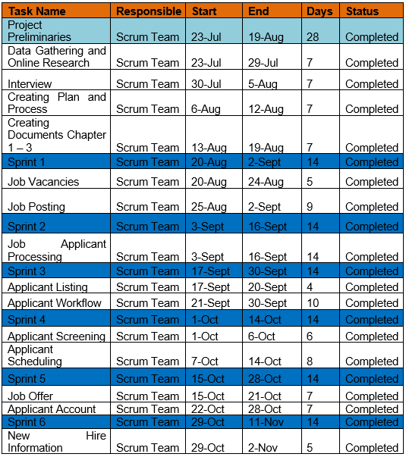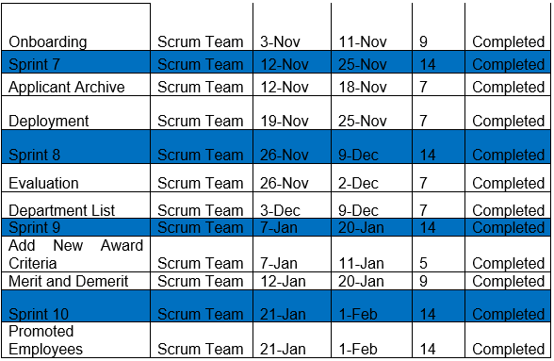

*Table 3: Project Plan*

* 1. 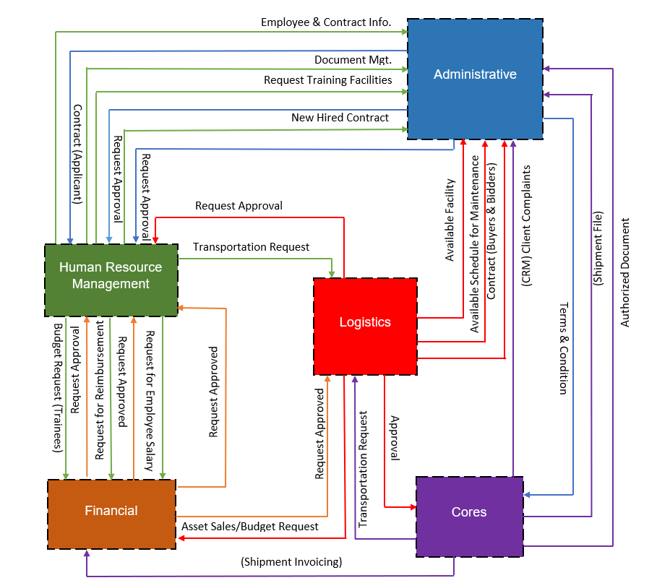**System Architecture**

*Figure 2: Top Level 1 System Architecture*

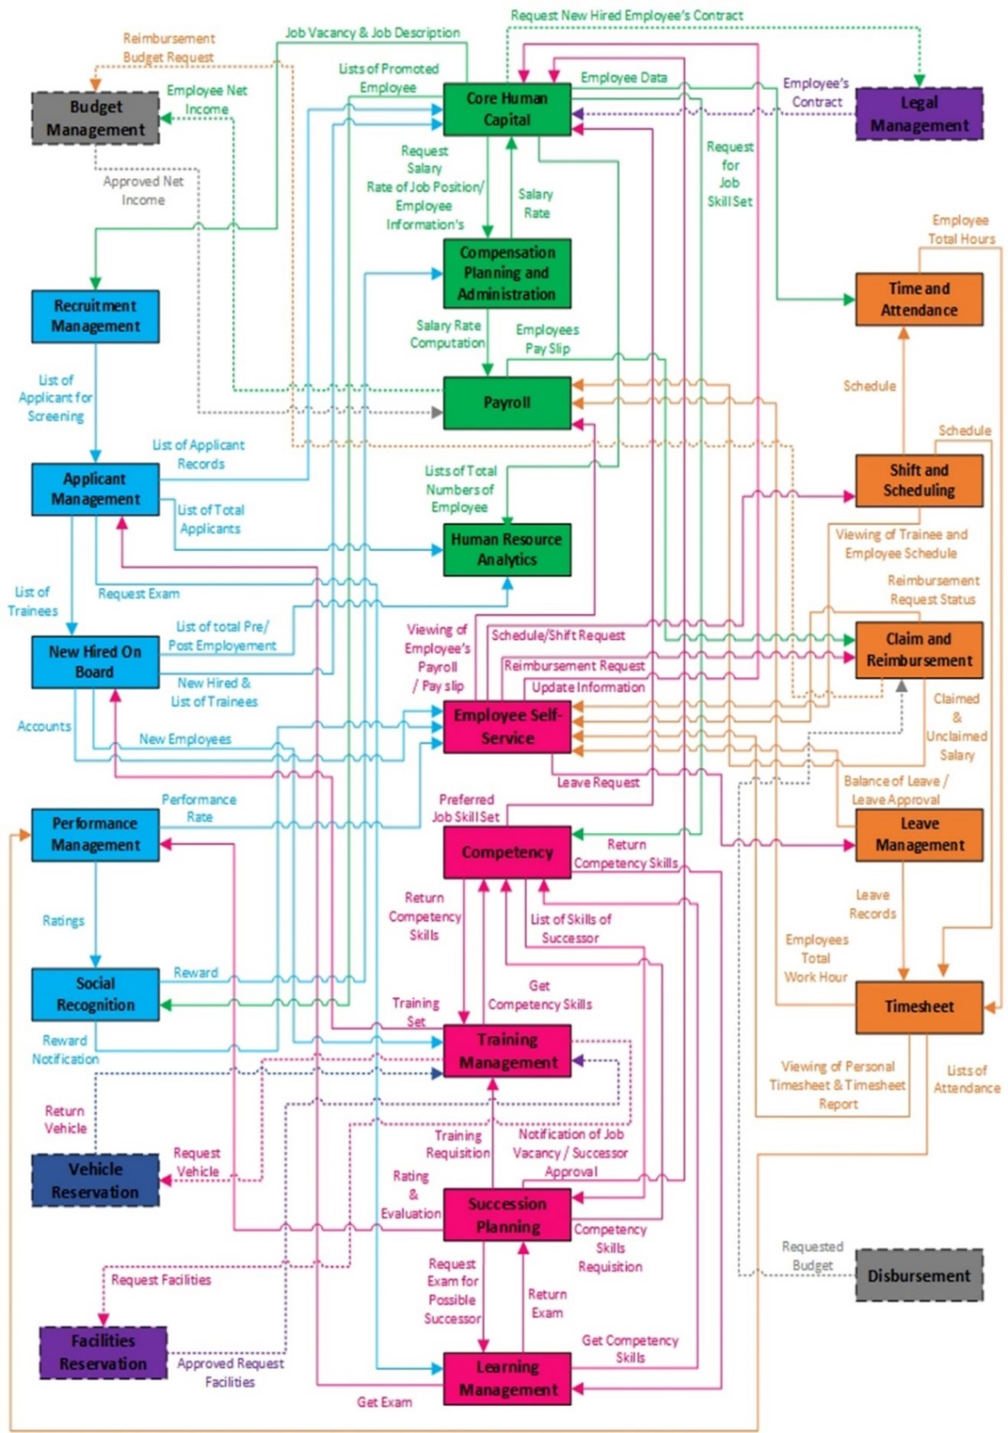

*Figure 3: Top Level 2 System Architecture*

HR1

HR2

HR3

HR4

FINANCIAL

LOG2

ADMIN

|  |  |
| --- | --- |
| **1.3.1 Business Architecture** | **C:\Users\Rogg\Desktop\PS2\recruitment.PNGRecruitment**  *Figure 4: Business Architecture of Recruitment*  **C:\Users\Rogg\Desktop\PS2\new hire.PNGNew Hired on Board**  *Figure 5: Business Architecture of New Hired on Board*  **Applicant Management**  **C:\Users\Rogg\Desktop\PS2\appli.PNG**  *Figure 6: Business Architecture of Applicant Management*  C:\Users\Rogg\Desktop\PS2\perf.PNG**Performance Management**  *Figure 7: Business Architecture of Performance Management*  **Social Recognition**  *Table 4: Business Architecture*  *Figure 8: Business Architecture of Social Recognition* |
| **1.3.2 Application Architecture** | Provider  Admin  Staff  Applicant  Consignee  Shipper  *Figure 9: Top Level 1 Application Architecture*    C:\Users\Rogg\Desktop\PS2\1.jpg  *Figure 10: Top Level 2 Application Architecture*  C:\Users\Rogg\Desktop\PS2\2.jpg  *Figure 11: Top Level 2.1 Application Architecture*  C:\Users\Rogg\Desktop\PS2\3.jpg  *Figure 12: Top Level 2.2 Application Architecture*  C:\Users\Rogg\Desktop\PS2\4.jpg  *Figure 13: Top Level 2.3 Application Architecture*  HR1  HR2  HR3  HR4  **User Levels:**   * **Level 1** * Applicants * **Level 2** * Human Resource Manager * Employees * Trainees * **Level 3** * Admins (Recruitment, Applicant Management, New Hired on Board, Social Recognition, Financial, Logistic 2, Administrative, Core Human Capital, Compensation, Payroll, Human Resource Analytics) * **Level 4** * Super Admin (Human Resource)   *Table 5: Application Architecture* |
| **1.3.3**  **Data Architecture**  **Database Schema: Recruitment, Applicant Management**  **NewHired on Board, Performance Management and Social Recognition**  **Database Schema: Recruitment, Applicant Management**  **New Hired on Board, Performance Management and Social Recognition**  *Table 6: Data Architecture*  *Figure 15: Top Level 2 Data Architecture* | *Figure 14: Top Level 1 Data Architecture*    **tbl1 hr1 jobPosted evap (aerolink)**  evap_id  jobPosted_id  created_at  updated_at  **tbl1 hr1 relationships (aerolink)**  id  relationship_id  created_at  updated_at  **tbl1 hr1 workflow (aerolink)**  workflow_id  workflow_name  created_at  updated_at  **tbl1 hr1 suffix (aerolink)**  id  suffix_name  created_at  updated_at  **tbl1 hr1 civil status (aerolink)**  id  civil_status  created_at  updated_at  **tbl1 hr1 applicants (aerolink)**  id  applicant_code  ansavepivot_id  firstname  lastname  middlename  suffix_id  date_of_bitrh  palce_of_birth  gender  email  civil_status_id  height  weight  contact_number  educAttain  prevSchool  resumeCV  created_at  updated_at  **tbl1 hr1 sc awardees (aerolink)**  id  employee_code  award_id  reward_id  remarks  date_posted  created_at  updated_at  **tbl1 hr1 workflow (aerolink)**  workflow_id  workflow_name  created_at  updated_at  **tbl1 hr1 sc add reward (aerolink)**  reward_id  reward_name  reward_remarks  date_added  date_posted  created_at  updated_at  **tbl1 hr1 evaluation criteria (aerolink)**  evac_id  evac_name  evac_desc  created_at  updated_at |
| **1.3.4 Technology Architecture** | |  |  | | --- | --- | | **Title** | **Descriptions** | | HTML5 | For AeroLink Webpage. | | CSS3 | Styling AeroLink Webpage. | | JavaScript | For Scripting AeroLink Webpage. | | Angular | For effective implementation of single web page design and  asynchronous client  – server responses. |  |  |  | | --- | --- | | **Title** | **Description** | | Composer | Package manager for PHP. | | Laravel | For AeroLink Webpage. | | Symfony | For supporting AeroLink Webpage. | | Bootstrap | For responsive Web design. | | NetBeans | For AeroLink desktop application. |  |  |  | | --- | --- | | **Title** | **Descriptions** | | Scene Builder | For front end design of AeroLink  desktop application. | | MongoDB | For Task Management. | | MSSQL | For AeroLink Database Server. | | Socket IO | For real time client server response  in webpage. |   *Table 7: Technology Architecture* |